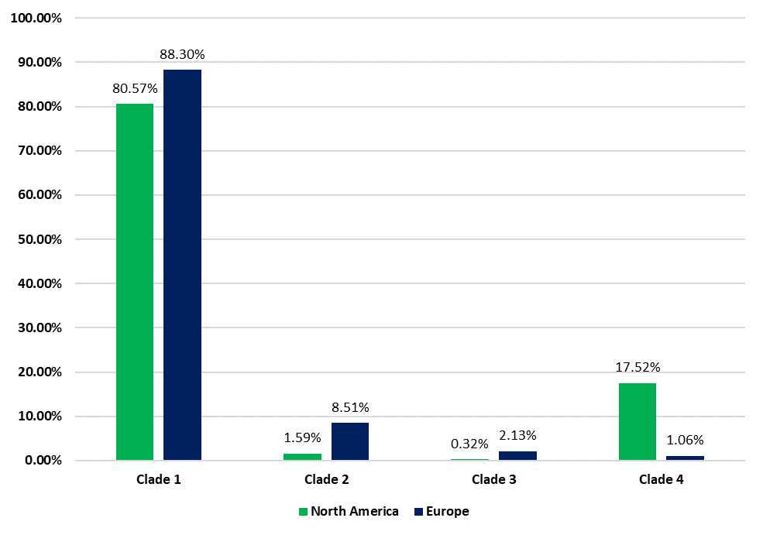
Percentage of isolates from each region that belonged to each of the four major clades of Haemophilus influenzae serotype a

